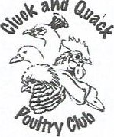
Cluck and Quack Poultry Club Show Entry Form

and
February 28th, 2026
Gainsborough Exhibitor Name_____________________________________
Community Club Address________________________________________________________
Portage La Prairie, MB __________________________________________
ENTRY FEE: $4.00 per bird Phone_______________________ E-Mail__________________________________
Breed and Variety  Example: Cochin - Blue | Bantam/  Standard | Cock  X 2 | Hen  X 3 | Cockerel  X 1 | Pullet  X2
There is a $10.00 Exhibitor Fee for all Open Exhibitors. Juniors are exempt. |  |  |  |  | $10.00
Please Mark One: OPEN CLASS____ JUNIOR CLASS____ Total Number Entries________x$4 = $____________
Callum McLeod, (AB) American Poultry Association Licensed Judge, will have the honor of judging the birds
Please print additional forms if more room is needed.
You may pay for your entries by cash at the show before cooping in or you may e transfer to candqpoultryclub@gmail.com please make password POULTRY
Please send entries to or for information contact Show Secretary: Kylie Wasiuta 36 Ferry Road Cartier, Manitoba R4K 1B2 or barrelracer_cwgrl@hotmail.com ENTRIES MUST BE RECEIVED BY Wednesday February 25th, 2026 (late entries or any changes or exchanges is $5.00 a bird)

The Cluck and Quack Poultry Club invite you to our
2026 The Cluck and Quack Poultry Show
February 28th 2026
Gainsborough Community Club,
Hwy 240 and Mile Road 62 N
Just 10 Minutes South of Portage La Prairie
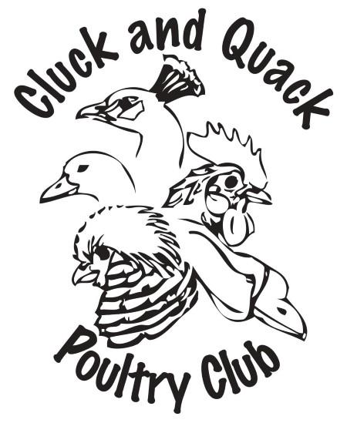

Sanctioning Association: American Poultry Association
Poultry Judge: Callum Mcleod, Blackie, Alberta
COOP IN TIMES: Friday, February 27th from 5pm to 9:00 pm and Saturday, February 28th from 7:30 to 9:00 am
COOP OUT TIMES*: Saturday, February 28th from 3:00pm-8:00pm, Sunday, February 29th 8:00-10:00 am
*Tear Down and removal of birds may begin following the Awards, this is just a rough estimate of Coop Out Times, it may be earlier.
Any help tearing down immediately following coop out is greatly appreciated

Host Hotel
Canad Inns Destination Centre
Portage La Prairie, MB
2401 Saskatchewan Ave W
R1N 4A6
1-204-857-9791
There are other hotel options as well, so feel free to google Hotels in Portage La Prairie

Rules of Show:
- Entries are open to all Standard Bred Poultry, including Chickens (Large Fowl & Bantam), Turkeys, Ducks, Geese, and Guineas.
- Entries are open to both members, and non-members of the Cluck and Quack Poultry Club. Please mark all entries as Junior or adult. Juniors are individuals under 16 years of age.
- Entries MUST be received by Wednesday February 25th, 2026. If choosing to snail mail entries please phone or email Kylie to let her know you have entries coming. It has happened in the past that due to mail strikes and slow mail that entries and payment were not received before the show. We do not want your entries to be missed due to slow mail.
- Please check in before cooping in birds. All entries must be paid in full before judging starts, cash, cheque, or Etransfer please. We do accept card payments but there will be a 3% processing fee added. Payment will be accepted at the Show Office table before judging starts. Make cheques payable to Cluck and Quack Poultry Club, you may mail it with your entry form or bring payment upon arrival at show grounds. All N.S.F. cheques returned will result in an automatic $25.00 service charge.
- Entries are $4.00 per bird for both Open and Junior exhibitors. In making an entry, the exhibitor agrees to be governed by the rules and regulations. There is one bird per cage.
- All entries must include Breed, Variety, and Sex on the entry form. All birds will be judged in the class as written on the entry form. You may make substitutions within class provided the class and section remains the same as the original entry. All breeds that include bearded and non-bearded or single comb and rosecomb varieties should be identified specifically.
- All specimens must be exhibited in their natural condition except for: All Old English Games, Modern Games and American Games Cocks and Cockerels - large and bantam - must be dubbed.
- All entries must be the property of the exhibitor at least 30 days prior to the date of the show.

- No birds will be shown from flocks which have had an infectious or contagious disease for at least six weeks prior to entry closing date. Exhibitors who make an entry do so with the distinct understanding that they abide by this regulation, and guarantee that their stock has been free from disease for the period stated.
- All entries must be clean and disease free. Entries are subject to refusal by the show board, void of refund. All sick birds will be removed from the show room by the Show Management. Neither the Cluck and Quack Poultry Club, nor its officers are responsible for any loss, sickness or injury to any birds brought to the show.
- This is a licensed American Poultry Association Show, and all applicable rules, point allotments apply. The latest revised American Standard of Perfection and American Bantam Standard shall be the guide in all Poultry Entries judged.
- The judge shall have power to withhold awards at his/her discretion and will be instructed to the effect that no award is to be given unless the exhibit is worthy. The judge’s decision is final.
- Feed and water will be supplied, but all exhibitors will be responsible for the feeding and watering of their own birds.
- There will be a lunch canteen available at the showroom on Saturday with a selection of hot and cold lunch items at affordable prices.
- Award presentation will take place Saturday afternoon, following the completion of the show.
- Sale coops are available to exhibitors for $4.00 a cage only on a limited basis, please contact us to book cages now as there are only a few available. Sale birds must be clean and disease free.
- Ribbons will be awarded for, Champion of Show, Reserve Champion of Show, Champion Waterfowl, Champion Standard, Champion Bantam and Champion Junior Exhibitor. Prizes are awarded to each Junior exhibitor.
Please send entries to, email entries are preferred, or if you are going to mail entries please phone or email Kylie to let her know that you have entries, we don’t want any entries missed due to late snail mail:
Kylie Wasiuta 36 Ferry Road Cartier, MB R4K 1B2 204-770-4420 barrelracer_cwgrl@hotmail.com

and
Cluck and Quack Club Poultry Show
2026 Show Schedule
Friday, February 27th, 2026
5:00 – 9:00 PM Friday evening coop in
9:00PM Building Closes
(If you are coming in from out of town late please let us know so we can have someone there to open the doors)
Saturday, February 28th, 2026
7:30 – 9:00 AM Building open to exhibitors and vendors
9:00 AM Coop in deadline for all entries. Building is open to the Public.
9:00 AM – 2:00 PM Judging Commences, followed by Awards
2:00 PM Building Closed to the Public. Begin tear down, all exhibitors, your help with tear down is appreciated ☺
Sunday, February 29th, 2026
Out of Province and local exhibitors release time if not all exhibitors have left on Saturday
Final tear down and clean up of venue, if required
Thank You for another Successful Show!

